Project Proposal Draft: Remote Construction Monitoring through Enhanced Satellite Imagery Analysis

Executive Summary
In this project, I propose to explore the capabilities of computer vision (CV) and satellite imagery analysis to detect changes in building footprints across diverse environments, ranging from urban to rural landscapes. Utilizing a subset of the high-resolution SpaceNet 7 dataset and enhancing Sentinel-2 imagery through super-resolution techniques, I aim to train a model that can accurately predict building footprint changes, irrespective of the geographical context. This approach seeks to advance the field of remote sensing by providing a flexible tool for monitoring urban development, utilizing freely available Sentinel-2 10m resolution imagery.

Problem Statement
Detecting changes in building footprints presents a significant challenge due to the varying quality and resolution of available satellite imagery. This limitation becomes even more pronounced when attempting to apply a single model across different terrains and development patterns. My project addresses this challenge by aiming to develop a CV model that is adaptable and accurate across a variety of imagery, by enhancing low-resolution images to improve prediction capabilities.

Dataset and Technology
To achieve this, I will use a selected subset of the SpaceNet 7 dataset for its detailed annotations and diverse global coverage. Additionally, I plan to employ pre-trained models from the WorldStrat dataset to upscale the resolution of freely available Sentinel-2 imagery. This dual approach will allow me to compare my model's performance on upscaled high-resolution imagery versus the standard 10m low-resolution images, providing insights into the effectiveness of super-resolution techniques in building change detection.

Justification of the Problem
The ability to accurately detect changes in building footprints from satellite imagery has wide-ranging applications, from urban planning and environmental monitoring to disaster response. Improving the resolution and quality of satellite images for CV applications represents a significant technological advancement, potentially increasing the accessibility and utility of satellite imagery for various stakeholders.

Computational Resources Estimate
I anticipate that this project will require significant computational resources, particularly for processing the large datasets and training the CV models. I plan to investigate the use of cloud computing platforms to access the necessary computational power. Collaborating with my mentor, I will refine these estimates.

Conclusion
This project represents an exciting opportunity to push the limits of machine learning in satellite imagery analysis. By developing a model capable of detecting building footprint changes across various landscapes, I hope to make a contribution to the advancement of remote sensing technologies and their applications.

GOAL: to train a CV model that performs building footprint change detection on time-series 10m satellite imagery

STEPS:
- Preprocess existing SpaceNet 7 dataset of 4m imagery and downscale it to a 10m imagery representation.
  - Could be done through a number of downsampling methods
- Build a baseline model that trains on this downscaled imagery along with the original building footprint labels from the SpaceNet 7 dataset.
  - Original SN7 Baseline: https://github.com/CosmiQ/CosmiQ_SN7_Baseline/blob/master/notebooks/sn7_baseline.ipynb
- Reproduce existing solutions for the 4m imagery challenge:
  - Could experiment with the varying architectures used by the top solutions submitted
    - 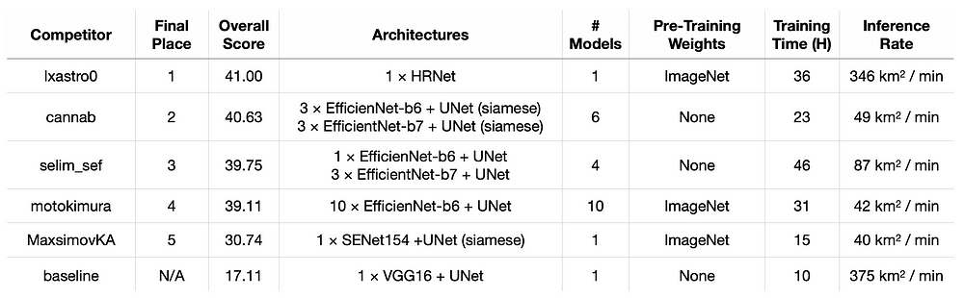
  - Could experiment with training these iterative models on a fraction of the downscaled dataset in order to reduce training times
- An additional approach I could try after reproducing these 4m solutions with the 10m dataset is hyper-resolving the 10m imagery up to 1.5m imagery using the pre-trained WorldStrat hyperresolution model.
  - This design could then use the same training process that the 10m model used by scaling the building footprint labels in the original dataset to the new 1.5m scale.

